Calculator Nim

This is a game for two players with one calculator between them. You may use only these keys.

Take turns to add a single-digit number to what is already in the calculator.

The winner is the player who makes the display show 30.

If you go over 30 you lose.

*Variations*

* Choose a different target number.
* Play the game using subtraction. In this case you must start by entering a number such as 60, and set a target of a smaller number, such as *25.*
* Make the target 200 or more, and add two-digit numbers.
* Play the game using multiplication. In this case start by putting I in the display, and set a target such as 1000.

Bull’s eye

Choose a starting number (for example, 17) and a target number (for example, 100).

Find which number to multiply the starting number by to give the target number, correct to an agreed degree of accuracy.



*Decigame*

A game for two players.

The winner is the first player to get three of their marks in a row without any of the other player’s marks in-between.

**Rules**

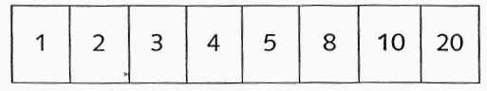

Take turns to choose two numbers from the table below:

* Divide one number by the other to make a number between 0 and 1.

• Mark your answer on the number line below:

• Numbers can be used more than once.

**Simplifications**

• Use a number line which is divided into tenths:



* Use a 0-100 number line and the numbers 1 to 10 in the table. Players

choose two numbers and multiply them together.

**Challenges**

* Use a 0-5 number line. Add the numbers 6, 9, 12, 15, 16 and 18 to the table.
* Use a 0-10 number line and the following numbers:

1.5 0.8 2.4 0.6 4.8 0.3 6.0 3.6

Choose two numbers and multiply or divide them.